Project Design Phase-II
Technology Stack (Architecture & Stack)

Date | 31 January 3035
Team ID | LTVIP2025TMID36086
Project Name | Enchanted Wings: Marvels of Butterfly Species
Maximum Marks | 4 Marks

Technical Architecture:
The Deliverable shall include the architectural diagram as below and the information as per the table1 & table 2
Example: Order processing during pandemics for offline mode
Reference: https://developer.ibm.com/patterns/ai-powered-backend-system-for-order-processing-during-pandemics/
Guidelines:
Include all the processes (As an application logic / Technology Block)
Provide infrastructural demarcation (Local / Cloud)
Indicate external interfaces (third party API’s etc.)
Indicate Data Storage components / services
Indicate interface to machine learning models (if applicable)


Table-1 : Components & Technologies:
S.No | Component | Description | Technology
 | User Interface | How user interacts with application e.g.  Web UI, Mobile App, Chatbot etc. | HTML, CSS, JavaScript / Angular Js / React Js etc.
 | Application Logic-1 | Logic for a process in the application | Java / Python
 | Application Logic-2 | Logic for a process in the application | IBM Watson STT service
 | Application Logic-3 | Logic for a process in the application | IBM Watson Assistant
 | Database | Data Type, Configurations etc. | MySQL, NoSQL, etc.
 | Cloud Database | Database Service on Cloud | IBM DB2, IBM Cloudant etc.
 | File Storage | File storage requirements | IBM Block Storage or Other Storage Service or Local Filesystem
 | External API-1 | Purpose of External API used in the application | IBM Weather API, etc.
 | External API-2 | Purpose of External API used in the application | Aadhar API, etc.
 | Machine Learning Model | Purpose of Machine Learning Model | Object Recognition Model, etc.
 | Infrastructure (Server / Cloud) | Application Deployment on Local System / Cloud  Local Server Configuration:  Cloud Server Configuration : | Local, Cloud Foundry, Kubernetes, etc.

Table-2: Application Characteristics:
S.No | Characteristics | Description | Technology
 | Open-Source Frameworks | List the open-source frameworks used | Technology of Opensource framework
 | Security Implementations | List all the security / access controls implemented, use of firewalls etc. | e.g. SHA-256, Encryptions, IAM Controls, OWASP etc.
 | Scalable Architecture | Justify the scalability of architecture (3 – tier, Micro-services) | Technology used
 | Availability | Justify the availability of application (e.g. use of load balancers, distributed servers etc.) | Technology used
 | Performance | Design consideration for the performance of the application (number of requests per sec, use of Cache, use of CDN’s) etc. | Technology used

References:
https://c4model.com/
https://developer.ibm.com/patterns/online-order-processing-system-during-pandemic/
https://www.ibm.com/cloud/architecture
https://aws.amazon.com/architecture
https://medium.com/the-internal-startup/how-to-draw-useful-technical-architecture-diagrams-2d20c9fda90d

🧠 Technical Architecture for: Enchanted Wings: Marvels of Butterfly Species

🖼️ Architecture Diagram Overview

+------------------+ U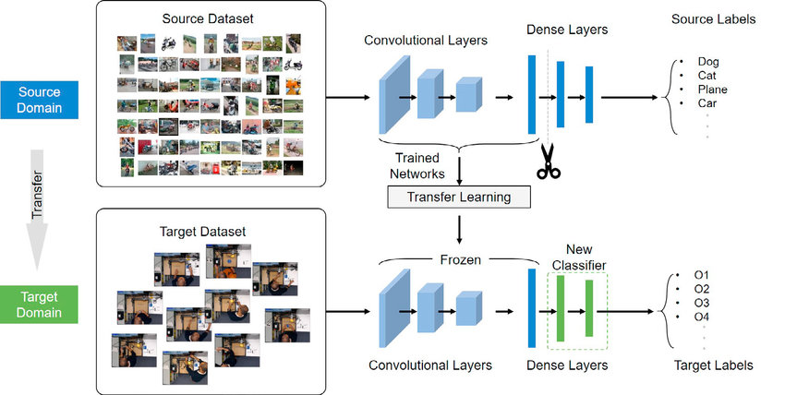

Upload Image +---------------------+
| User | -------------------------> | Streamlit Frontend |
| (Researcher/ | | (Web Interface) |
| Student) | +---------------------+
|
v
+-----------------------------+
| Preprocessing Pipeline |
| (Resizing, Normalizing) |
+-----------------------------+
|
v
+--------------------------------------+
| VGG16-based Butterfly Classifier |
| (Pre-trained Transfer Learning CNN) |
+--------------------------------------+
|
v
+--------------------------------------------------+
| Display Prediction + Species Info + Charts |
| (Confidence Score, Scientific Name, Distribution)|
+--------------------------------------------------+

📋 Table-1: Components & Technologies
S.No | Component | Description | Technology
1 | User Interface | Web interface for uploading butterfly images & displaying results | HTML, CSS, JavaScript, Streamlit
2 | Application Logic-1 | Model loading, prediction, result formatting | Python
3 | Application Logic-2 | Preprocessing pipeline (resizing, normalizing images) | OpenCV, NumPy
4 | Application Logic-3 | Visualization and plotting of training results | Matplotlib, Seaborn
5 | Database | Store feedback, usage logs | SQLite / Firebase
6 | Cloud Database | Optional storage of dataset and results for analysis | Google Firebase / AWS S3
7 | File Storage | Image datasets and prediction logs | Local File System / Google Drive
8 | External API-1 | Pull butterfly information based on species name | Wikipedia API
9 | External API-2 | Optional geolocation metadata of image | Google Maps API (if used)
10 | Machine Learning Model | Transfer learning-based classifier for butterfly species | VGG16 via TensorFlow / Keras
11 | Infrastructure | Deployed as local demo or cloud Streamlit App | Localhost / Streamlit Cloud / Heroku

📋 Table-2: Application Characteristics
S.No | Characteristics | Description | Technology
1 | Open-Source Frameworks | Keras, TensorFlow, Streamlit, Scikit-learn, Matplotlib | Python Libraries
2 | Security Implementations | Secure file upload, HTTPS enabled if hosted, access logs | SHA-256 (if login), HTTPS, Firebase Auth
3 | Scalable Architecture | Modular logic, separated model + interface, support for re-training | 3-tier architecture
4 | Availability | Available via Streamlit Cloud with continuous deployment | Streamlit Sharing / Heroku
5 | Performance | Pre-trained model reduces inference time; caching with @st.cache_resource | TensorFlow Lite (for optimization), CDN

✅ References
- https://c4model.com/
- https://developer.ibm.com/patterns/
- https://aws.amazon.com/architecture
- https://medium.com/the-internal-startup/how-to-draw-useful-technical-architecture-diagrams-2d20c9fda90d

